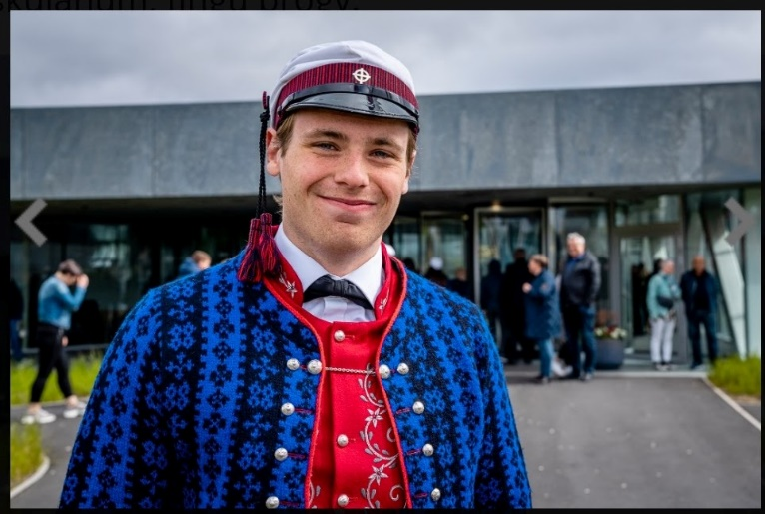**Hákun Poulsen**

**Personal Information**

* **Address:** [åbolevard 50 1 t.v]
* **Phone:** +45 93898179, +298 259994
* **Email:** hakun.poulsen@gmail.com
* **Date of Birth:** 25-06-2000

**About me**

I am a student at the Technical University of Denmark (DTU) studying environmental engineering. Originally from the Faroe Islands, I have gained a wide range of experiences since starting work at the age of 13. These roles have taught me valuable skills in hospitality, communication, and resilience. I thrive in outdoor environments, embrace challenges, and enjoy playing music.

**Education**

* **BSc in Environmental Engineering** - Technical University of Denmark (DTU) (2023-)
* **Studentereksamen (High School Diploma)** - Glasir Tórshavn College, Faroe Islands (2018-2021)

**Work Experience**

* **Carpenter** (2022-2023)
  + Detailed experience in carpentry, focusing on sustainable and efficient building practices.
* **Educator for Children with Special Needs** (2021-2023)
  + Developed and implemented educational programs to prepare children with special needs for school.
* **Recreational school** (2021 -2023)
  + Took care of children and helped them develop both as persons and in intrests. This was done by planning and making multiple competions in the forms of sports and some in creativety, also swimming with the kids once a week. All the kids where from first to second grade
* **Main Waiter & Wine Menu Manager** - Ræst, Tórshavn (2017-2019)
  + Managed wine selections and service standards, enhancing dining experience and customer satisfaction.
* **Bar Staff** - Multiple locations including Cafe Svejk, Frederiksberg, and Mikkeller Tórshavn (2019-2023)
  + Provided high-quality service in fast-paced environments, managing customer relations and beverage services.
* **Fish Ship Unloader** (2015-2019)
  + Coordinated the unloading processes, ensuring efficiency and compliance with safety regulations.
* **Burger King Staff Member** (2017)
  + Performed various roles from cashier to food preparation, maintaining fast service and quality standards.
* **Dishwasher to Waiter** - Áarstova and Barbara Fish House, Tórshavn (2013-2017)
  + Progressed from initial roles in kitchen maintenance to full responsibility as a waiter, enhancing team efficiency and customer service.
* **Local Santa Claus for the municipality**  (2019- )
* Spread holiday cheer across hospitals, kindergartens, and public space
* **Climbing instructor** (2019)

Served as a climbing instructor at the World Scout Jamboree (WSJ), guiding participants in safe climbing techniques.

**Organized events:**

**Scoting camps:**

* Organized and co-organized 50 scouting camps for children aged 5th to 10th grade.

**Training camps:**

* Coordinated 4 major rowing training camps with approximately 120 participants.

**Winther parties (christmas parties):**

* Planned 1 work-related Christmas party for staff, 1 for scout leaders, and 5 for scouts and their families.

**Skills**

• Project Management  
• Team Leadership  
• Customer Service Excellence  
• Carpentry and Manual Dexterity  
• Special Needs Education  
• Beverage and Hospitality Management  
• Python  
• LaTeX  
• Microsoft Word, PowerPoint, Excel  
• Q-GIS  
• Maple

**Additional Information**

* **Sports:** Rowing (since 2014), Swimming (2007-2014), Bow Shooting (2014-2017), Badminton (2011-2015), climbing (since 2017)
* **Music:** Guitar player since 2014, piano (2023)
* **Scouting:** Active scout since 2012, developing skills in leadership, survival, and community service.